Problem 1. Write a Java program to find the sum of all odd numbers in an array.

Code: 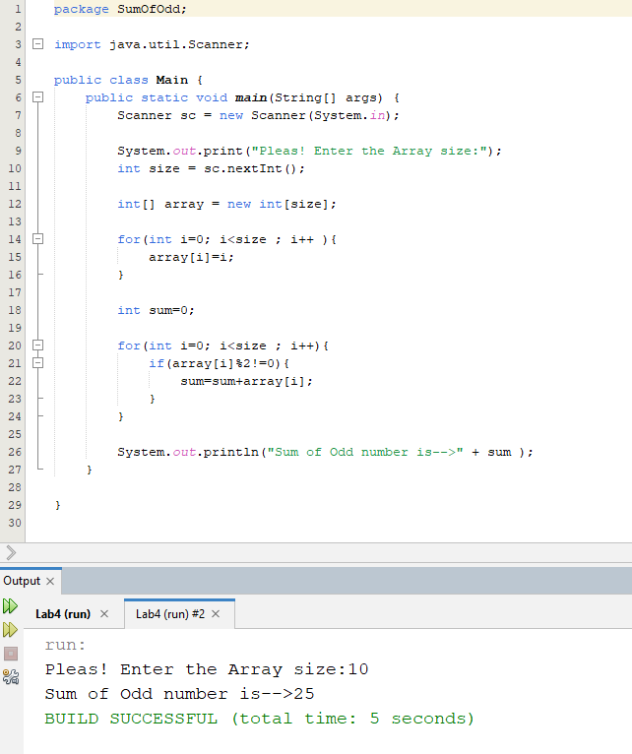

Problem 2. Write a Java program that takes two arrays as input, calculate the index wise sum of these arrays, and store the result in a third array.

Code: 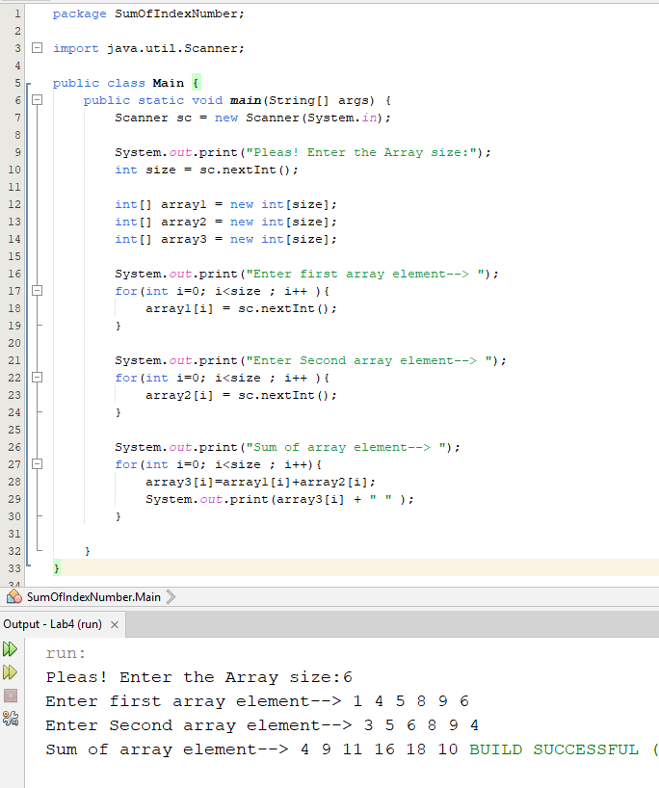

Problem 3. Write a Java program to search an element in an array.

Code: 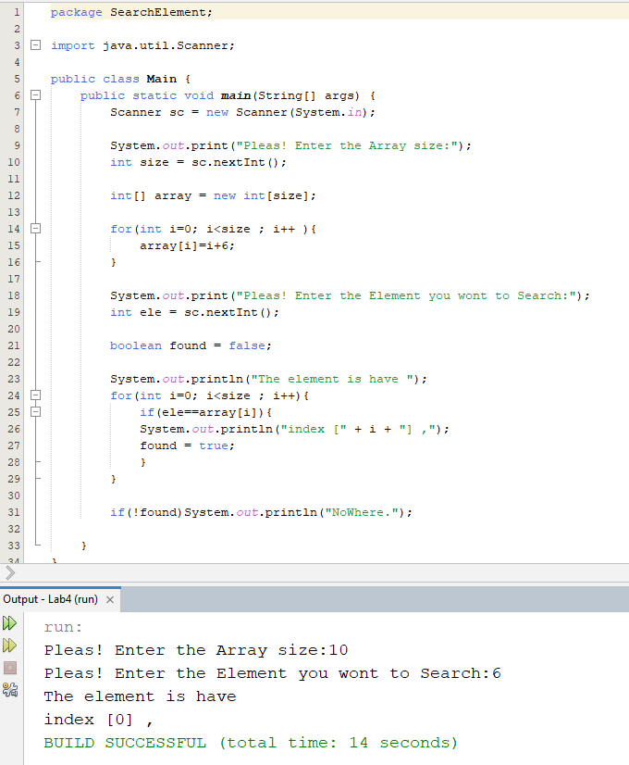

Problem 4. Write a Java program to reverse the elements in an array without using a second array.

Code: 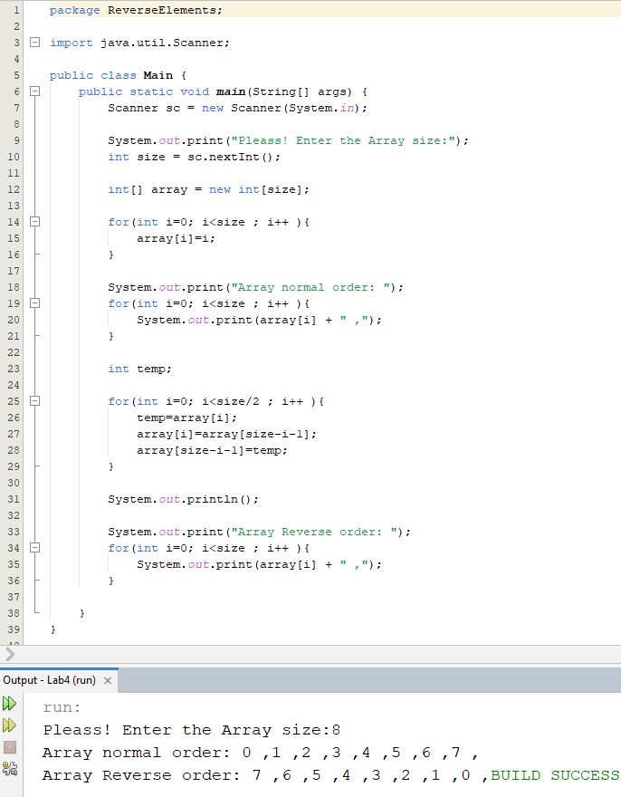

Problem 5. Write a Java program to find the second highest element of an array.

Code: 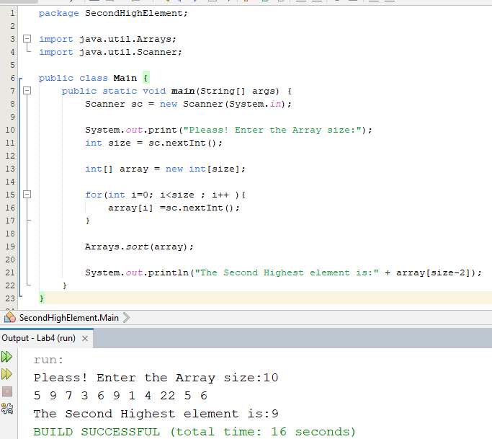

Problem 6. Write a Java program that calculates the average of an array, excluding the highest and lowest values in the array.

Code: 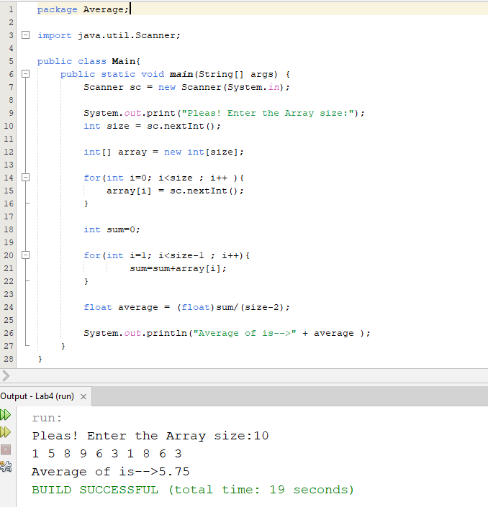

Problem 7. Write a Java program to calculate the sum of all the prime numbers in a 20 array.

Code: 